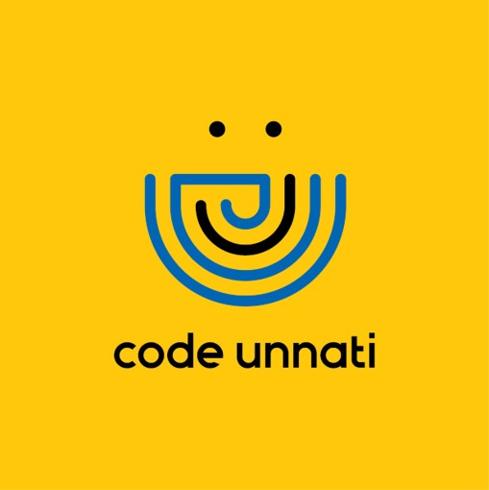 |  | 

Smart AI Surveillance & Alert System using YOLO
PROBLEM STATEMENT
Traditional CCTV systems mainly perform passive recording and require continuous human monitoring. This process is inefficient and prone to errors, as important events may be missed. There is also no provision for real-time alerts or centralized monitoring. Hence, an intelligent system is required to automate detection and improve surveillance efficiency.
PROJECT OVERVIEW
The Smart AI Surveillance and Alert System uses YOLO-based object detection to identify objects such as people and vehicles from live CCTV feeds. It integrates IP cameras through RTSP streams and processes video frames in real-time. The system provides a centralized dashboard and generates alerts when predefined conditions are detected, improving monitoring and response.
SOLUTION OFFERED
The system includes CCTV input, a YOLO-based detection module, and a monitoring dashboard. Video frames are analyzed in real-time to detect objects. The dashboard displays live feeds along with detection results, while the alert system notifies users of important events. This reduces manual effort and improves accuracy.
END USERS
- Traffic Management Authorities
- Home Owners
- Security Agencies
- Organizations and Offices
- Smart City Systems
TECHNOLOGY USED
Frontend: HTML, CSS, JavaScript
Backend: Python (OpenCV, YOLO) / Flask
Database: Optional (MongoDB / MySQL)
Libraries: OpenCV, NumPy
Tools: Jupyter Notebook, VS Code, GitHub

